**[Jenkins](https://jenkins.io/" \t "_blank)**®is an open-source automation server. With Jenkins, organizations can accelerate the software development process by automating it. Jenkins manages and controls software delivery processes throughout the entire lifecycle, including build, document, test, package, stage, deployment, static code analysis and much more.

You can set up Jenkins to watch for any code changes in places like SVN and GitHub, automatically do a build with tools like Ant and Maven, utilize container technology such as Docker and Kubernetes, initiate tests and then take actions like rolling back or rolling forward in production.

### Jenkins Today: Evolved to Continuous Delivery

Originally developed by Kohsuke for continuous integration (CI), today Jenkins orchestrates the entire software delivery pipeline – called continuous delivery. For some organizations automation extends even further, to continuous deployment. Continuous delivery (CD), coupled with a[DevOps culture](https://www.cloudbees.com/devops), dramatically accelerates the delivery of software.

Jenkins is the most widely adopted solution for continuous delivery, thanks to its extensibility and a vibrant, active community. The Jenkins community offers more than [1,400 plugins](https://plugins.jenkins.io/) that enable Jenkins to integrate with virtually any tool, including all the best-of-breed solutions used throughout the continuous delivery process. Jenkins continues to grow as the dominate solution for software process automation, continuous integration and continuous delivery and, as of February 2018, there are [more than 165,000 active installations](http://stats.jenkins.io/jenkins-stats/svg/svgs.html) and an estimated 1.65 million users around the world.

The Jenkins project is an independent open source community under the umbrella of a non-profit organization [Software in the Public Interest](http://en.wikipedia.org/wiki/Software_in_the_Public_Interest), which owns the key project assets including the Jenkins trademark. The project has its own [decision-making process](https://jenkins.io/project/governance/) and a [governance board](https://wiki.jenkins.io/display/JENKINS/Governance+Board).

### Cloud Bees and the Jenkins Community

****

Cloud Bees is an active participant in the Jenkins community and plays a significant role in supporting the project. A number of key contributors to the Jenkins project are employed by Cloud Bees. In support of the community, Cloud Bees is the lead sponsor of [DevOps World | Jenkins World](https://www.cloudbees.com/jenkinsworld), the annual user conference for the Jenkins community. Jenkins World enables the community to gather, fosters a sense of community, allows users to learn from each other and supports community growth. Cloud Bees has also supported the growth of [Jenkins Area Meetups (JAMs)](https://jenkins.io/projects/jam/) around the world.

Engineers from the Cloud Bees support and product teams regularly contribute code to the Jenkins project, are active in Jenkins IRC channels and project meetings, and contribute to the Jenkins project mailing lists. Several of the key projects Cloud Bees has developed include [Jenkins X](https://jenkins-x.io/), [Blue Ocean](https://jenkins.io/projects/blueocean/) and [Jenkins 2](https://www.cloudbees.com/press/jenkins-2.0-advances-continuous-delivery-native-pipeline-support-and-usability-enhancements). Additionally, all fixes made by Cloud Bees in the open-source code are donated back to the project – which helps us all to enjoy an ever-higher quality Jenkins experience.

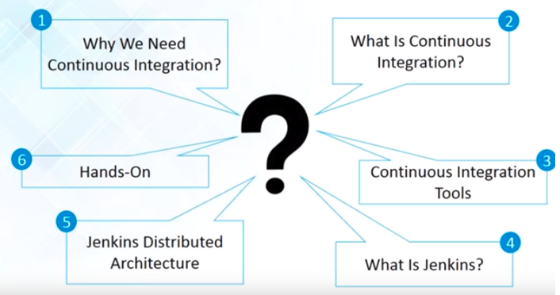

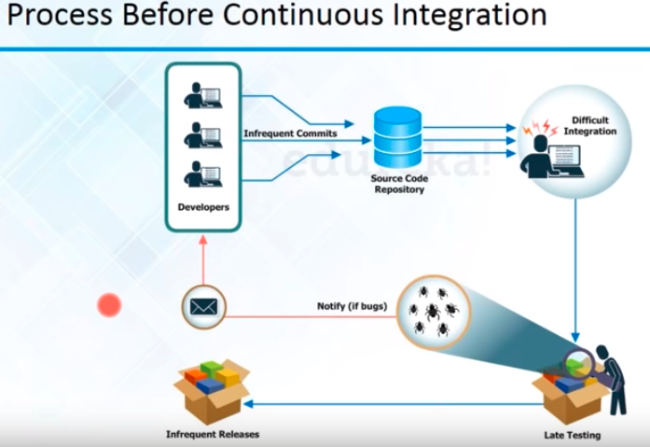

**Before**

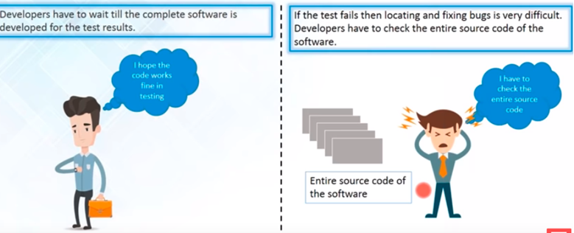

**After Continuous Integration came to Rescue**

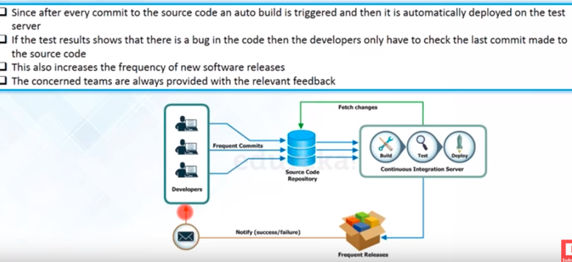

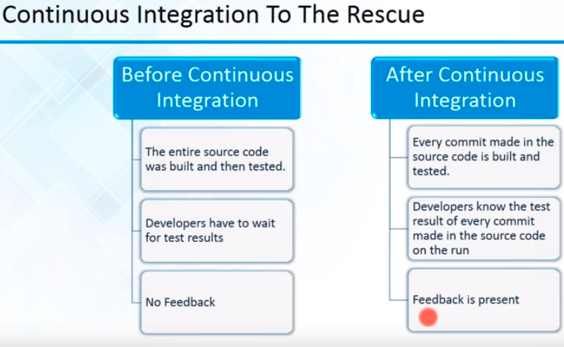

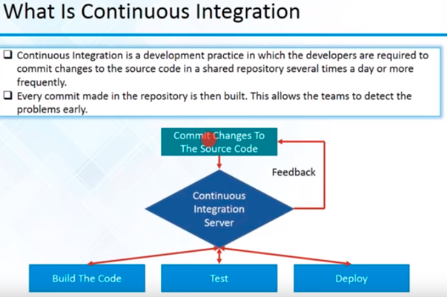

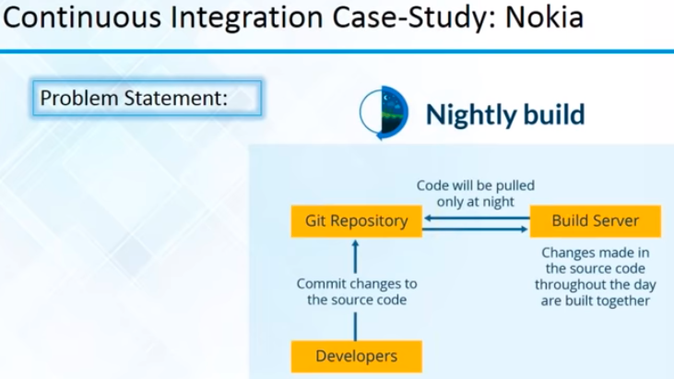

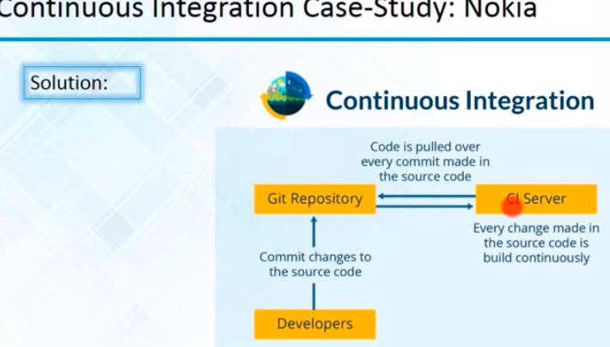

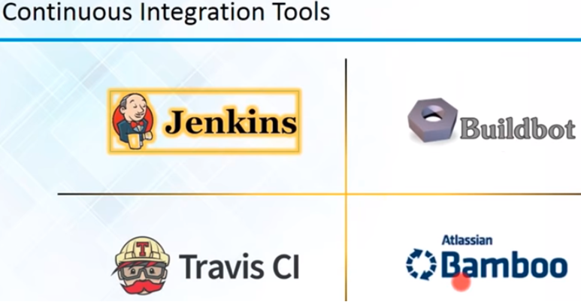

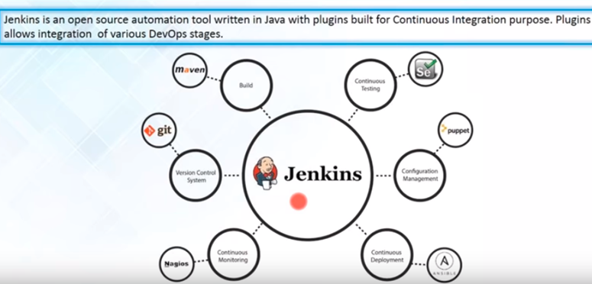

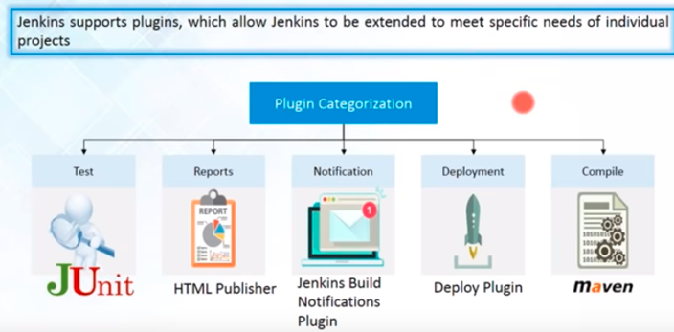

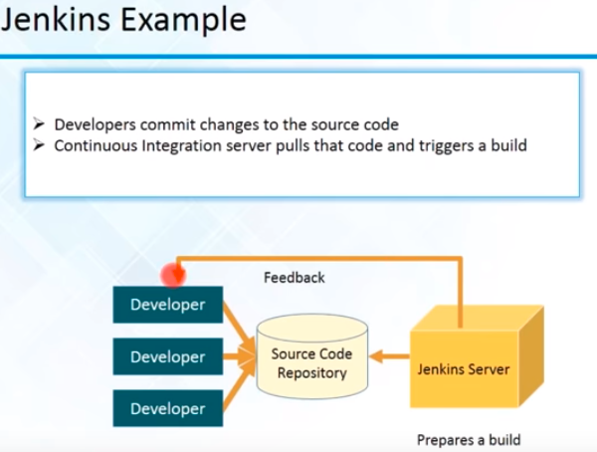

Dev – Check in – SCM

Build – integrate – Deliverables (artifacts)

QA – Testing

Full – Nightly Build

Continuation Integration Process